**Answer ALL the questions.**

1) Declare this matrix in array forms

i) 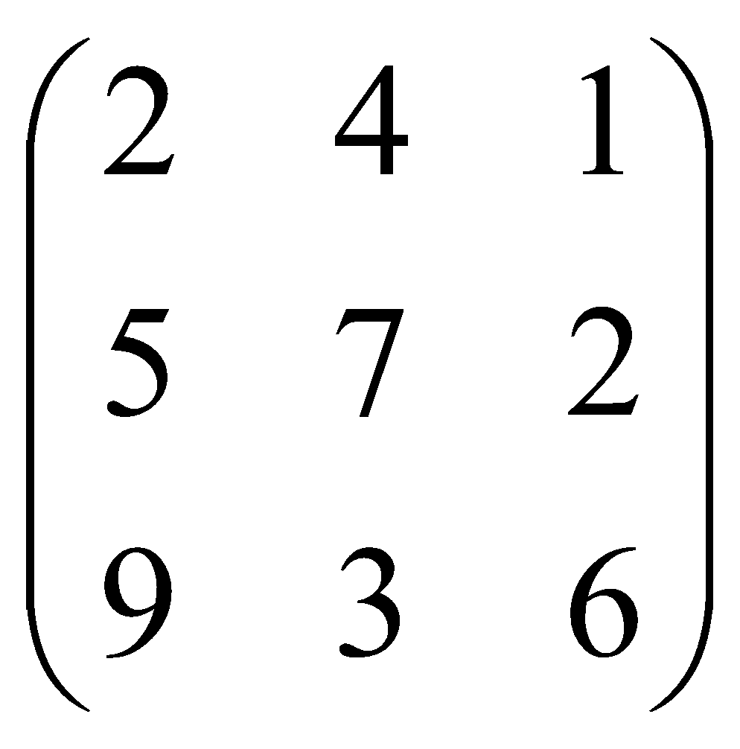 ii) 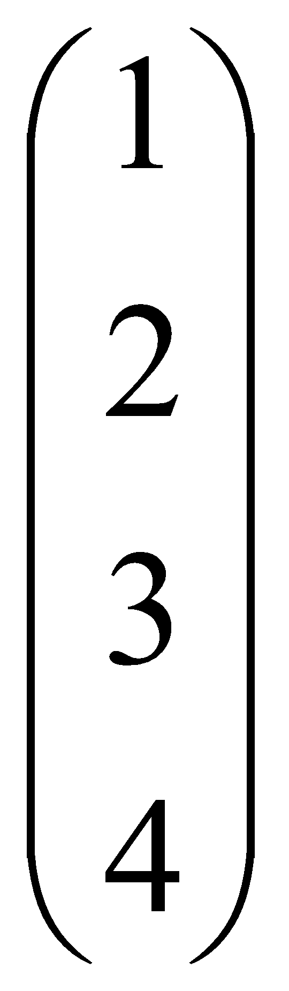 iii) 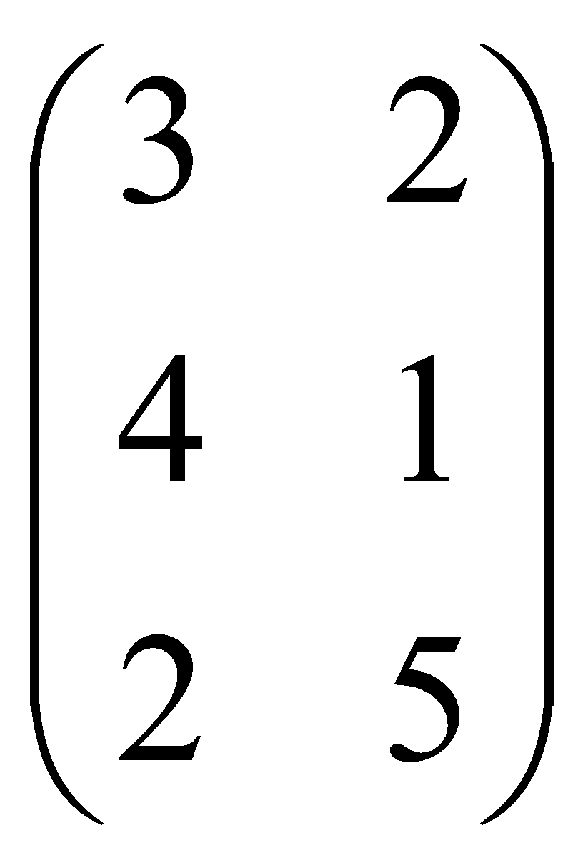

i) int a[3][3]

ii) int a[4][1]

iii) int a[3][2]

2) Declare this list of data in array forms

1. score1 = 82, 93, 73, 65, 78, 100. int score1[6]={82, 93, 73, 65, 78, 100};

int score1[2][3]={82, 93, 73, 65, 78, 100};

1. M0 = 23.13, M1 = 12.4, M2 = 32.5, M3 = 54.3 float M[4]={23.13, 12.4, 32.5 54.3}

3) Given

int matrix1[3][3] int matrix2[3][3]

 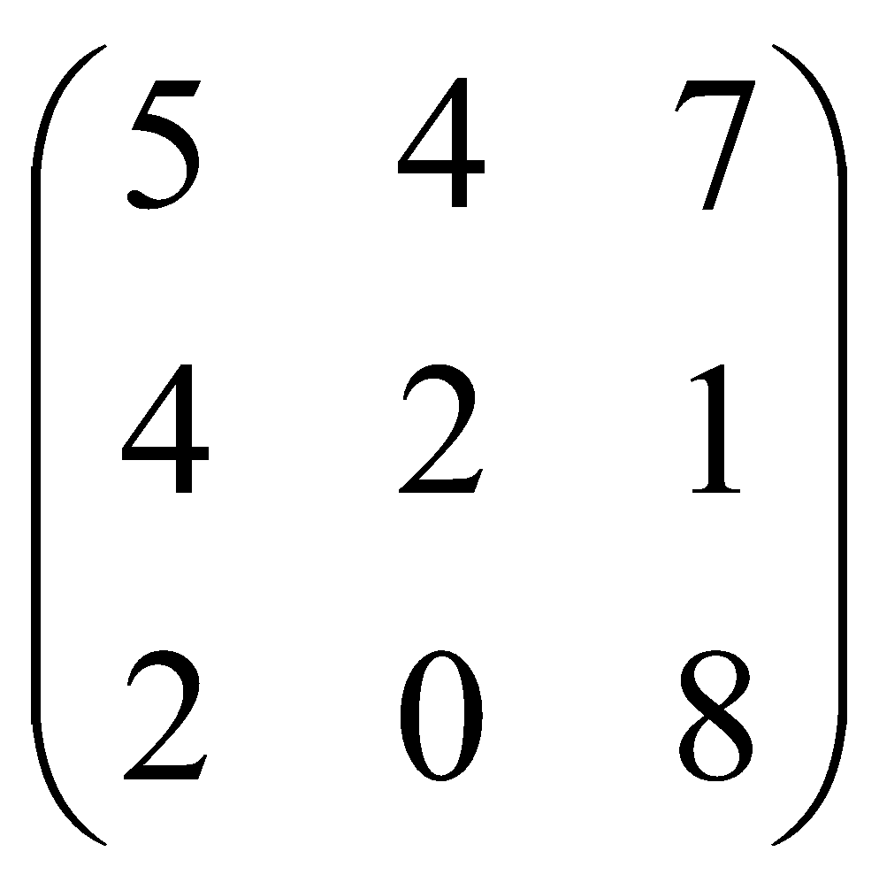

1. matrix1[0][0] + matrix2[1][2] = 2 + 1 = 3
2. matrix2[1][0] – matrix1[2][2] = 4 - 6 = -2

iii) matrix1[2][0] –( matrix1[2][1] + matrix2[2][0]) = 9 - (3+2)=4

iv) matrix2[2][1] x matrix1[1][2] = 0 x 2 = 0

4) Which is valid/invalid declaration?

a)int natsu[2][2] = {1, 2, 3 ,4 } valid

b)float gaban[][2] = {0.1, 2.34 , -31.3 ,4.002 } valid. unassigned value for number of rows is permissible.

c)int daimyo[][] = {1, 2, 3 ,4 } invalid. must have value for column

d) double sharingan[2][] = {1.3456, 2.000, 3.12 ,4.0 } invalid. must have value for column

1. Which is invalid code in the program below and give your reason?

#include<stdio.h>

int main(){

int disp[2][3];

int first[][**2**]={1,2,3,4};

int second[][2]={1,2,3,4};

int i, j;

for(i=0; i<2; i++)

**for(j=0; j<3; j++)**

{

printf("Enter value for disp[%d][%d]:", i, j);

scanf("%d", &disp[i][j]);

}

printf("Two Dimensional array elements:\n");

**for(i=0; i<2; i++)**

for(j=0;j<3;j++) {

printf("%d ", disp[i][j]);

if(j==2){

printf("\n");

}

}

printf("Elements of second:\n");

for(i=0; i<2; i++) {

for(j=0;j<**3**;j++) {

printf("%d \n", second[i][j]);

}

}

return 0;

}

1. Write a program to read a double dimensional array integer of order 3×4. Find out the sum of element and then **display entered array as well as sum of these elements** on the screen.

**Natalia**

#include<stdio.h>

void display(int);

int main ()

{

int n,i, sum=0;

int matrix[3][4];

for(i=0; i<=2; i++)

{

for(n=0;n<=3;n++)

{

printf("Enter the value of a[%d][%d]: ", i,n);

scanf("%d", &matrix[i][n]);

}

}

printf(“\n”);

display(matrix);

for(i=0; i<=2; i++)

{

for(n=0;n<=3;n++)

{

sum = sum + matrix[i][n];

}

}

printf("The sum of the elements are %d !!\n", sum);

printf("Amazing !!\n");

printf("*********************************");

}

void display(int matrix[3][4])

{

int n,i;

printf("*********************************");

printf("\n");

for(i=0; i<=2; i++)

{

printf("| ");

for(n=0;n<=3;n++)

{

printf("%d", matrix[i][n]);

}

printf(" |\n");

}

}

//******using sub program******

#include<stdio.h>

void display(int x[3][4]);

int main ()

{

int n,i, sum=0;

int matrix[3][4];

for(i=0; i<=2; i++)

{

for(n=0;n<=3;n++)

{

printf("Enter the value of a[%d][%d]: ", i,n);

scanf("%d", &matrix[i][n]);

}

}

printf("\n");

display(matrix);

for(i=0; i<=2; i++)

{

for(n=0;n<=3;n++)

{

sum = sum + matrix[i][n];

}

}

printf("The sum of the elements are %d !!\n", sum);

printf("Amazing !!\n");

printf("*********************************");

}

void display(int matrix[3][4])

{

int n,i;

printf("*********************************");

printf("\n");

for(i=0; i<=2; i++)

{

printf("| ");

for(n=0;n<=3;n++)

{

printf("%d", matrix[i][n]);

}

printf(" |\n");

}

}

//**************END*********************

**amira**

#include<stdio.h>

int main()

{

int r,c;

float mat[3][4], tot=0;

for(r=0; r<3; r++)

{

for(c=0; c<4; c++)

{

printf("Enter for [%d][%d]: ", r+1, c+1);

scanf("%f",&mat[r][c]);

tot+=mat[r][c];

}

}

printf("\nDisplay Array: \n");

for(r=0; r<3 ;r++)

{

for(c=0; c<4; c++)

{

printf("%.2f\t",mat[r][c]);

}

printf("\n");

}

printf("\nThe sum of element is %.2f\n",tot);

return 0;

}

**Intan**

#include<stdio.h>

int main()

{

int c,r;

float total;

float matrix[3][4];

printf("*************The Sum Of the Elements****************\n\n");

for(r=0;r<3;r++)

{

for(c=0;c<4;c++)

{

printf("Please enter the value for [%d][%d]=",r+1,c+1);

scanf("%f",&matrix[r][c]);

total+=matrix [r][c];

}

}

printf("\nThe Array is :\n");

for(r=0;r<3;r++)

{

for(c=0;c<4;c++)

{printf("%f\t",matrix[r][c]);

}

printf("\n");

}

printf("\nThe Sum of the elements is %.3f\n",total);

return 0;

}

ASHA

#include<stdio.h>

int main()

{

int i,j;

float total=0.00;

float arr[3][4];

for (i=0;i<3;i++)

{

for (j=0;j<4;j++){

printf ("Insert value for [%d][%d] : \n",i,j);

scanf("%d",&arr[i][j]);

total += arr[i][j];

}

}

printf ("The array is :\n ");

for (i=0;i<3;i++)

{

for (j=0;j<4;j++){

printf("%.2f \t",arr[i][j]);}

printf ("\n");

}

printf ("The sum of element is %.2f\n",total);

return 0;

}

**AMIRUL**

#include<stdio.h>

int main()

{

int a[3][4],i,j;

int sum = 0;

printf("Enter value for elements in the array\n");

for(i=0; i<3; i++)

{

for(j=0;j<4;j++)

{

printf("elements - [%d][%d]:", i, j);

scanf("%d", &a[i][j]);

}

}

printf("\nTwo Dimensional array elements:\n");

for(i=0; i<3; i++)

{

for(j=0;j<4;j++)

{

printf("%d ", a[i][j]);

if(j==3)

{

printf("\n");

}

}

}

for(i=0;i<3;i++)

{

for(j=0;j<4;j++)

{

sum = sum + a[i][j];

}

}

printf("\nSum of elements is %d\n",sum);

return 0;

}

1. Write a program in C to read an array of the integer of order 4×4. Find out the sum of only those elements which is either divisible by 3 or 7. Display sum of these elements and entered array in tabular format on the screen.

iffah

#include<stdio.h>

int main()

{

int a[4][4],b[4][4],c[4][4],i,j,sum=0;

for(i=0;i<4;i++){

for(j=0;j<4;j++){

printf("a[%d][%d]= ",i+1,j+1);

scanf("%d",&a[i][j]);

}

printf("\n");

}

for(i=0;i<4;i++)

{

for(j=0;j<4;j++)

{

if(a[i][j]%3==0||a[i][j]%7==0)

sum+=a[i][j]

}

}

printf(“Sum is %d”,sum);

return 0;

}